Year 2
Parent Booklet
Dear Parents,
In light of parents evening, it has come to our attention that many of you are concerned over gaps in your child’s education and wellbeing around COVID-19 and lockdowns. We appreciate this and have taken on board all of your worries, please remember that every child is in their own boat in the same storm. You are not alone in how you are feeling and we are here to support you.
For a lot of children routine and consistency is very important however please bear with us for timetable/teacher changes. Please note that all four teachers work very closely together to share information.
We appreciated your gratitude and hearing how happy your children are this year. We have put together some of the things we are working on and how you can help if you wish. If your child finds something too difficult try the objectives from a previous year group as this is what we do in class. Feel free to post any work on Seesaw and we will reward them in class.
Kind Regards,
Mr Cull and Miss Hadfield.

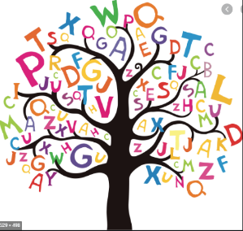
Spellings
The national curriculum advises that children from each year group should learn a set of age appropriate words. Find the appropriate age group for your child in the link below.
https://assets.publishing.service.gov.uk/government/uploads/system/uploads/attachment_data/file/239784/English_Appendix_1_-_Spelling.pdf
Spellings are posted on Seesaw half termly and they follow the Year 2 spelling rules. See link to government website. You could always go back over spellings to see if your child is able to retain the spelling rules.
Reading
The class teacher reads with every child once a week. During this time they will be questioning children on the book and encouraging them to read new words using phonics strategies. The teacher will be checking that your child is reading at least one of their home reading books every weekend (Friday – Tuesday) and their reading record is dated and signed by an adult or sibling (+16). There are reward systems in place to encourage your child to read to you.
To support your child with Phonics, we now have access to Phonics Play. There are a lot of fun interactive games that your child will enjoy.
www.phonicsplay.co.uk
Username- bjps2020
Password- phonics2020
Maths
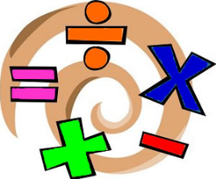
We are currently following WhiteRose. If you wish, please find a link below which will give you access to schemes of learning, assessment sheets for each topic/term, parent workbooks, problem of the day and an interactive whiteboard. We are covering objectives from year 1 and 2.
https://whiterosemaths.com/resources/primary-resources/
So far, we have completed the following topics; Place value, Addition and Subtraction. We are starting Money followed by Multiplication and Division. Their learning can be further supported by the booklet we have put on Seesaw. This can be dipped in and out of and there is no need to complete pages in their entirety.
Below you will find links for fun maths activities related to our topics.
https://www.topmarks.co.uk/
https://www.bbc.co.uk/bitesize/subjects/z826n39
English
We try to do a piece of writing once a week. We spend lots of time building up to this through drama, phonics, grammar lessons and highly structured planning. We encourage the children to take pride in their work through presentation and handwriting. It is also a new skill in Year 2 that they can re-read their sentences and check they make sense.
Handwriting
It is imperative that children know how to form all letters correctly. Please use the handwriting activities uploaded on Seesaw to practise with your child.

