Year 4
Parent Booklet
Dear Parents,
In light of parents evening, it has come to our attention that many of you are concerned over gaps in your child’s education and wellbeing around COVID-19 and lockdowns. We appreciate this and have taken on board all of your worries, please remember that every child is in their own boat in the same storm. You are not alone in how you are feeling and we are here to support you.
For a lot of children routine and consistency is very important however please bear with us for timetable/teacher changes. Please note that all four teachers work very closely together to share information.
We appreciated your gratitude and hearing how happy your children are this year. We have put together some of the things we are working on and how you can help if you wish. If your child finds something too difficult try the objectives from a previous year group as this is what we do in class. Feel free to send in any work your child does at home and we will reward this!
Kind Regards,
Mrs Rose & Miss Grimsditch.

Spellings
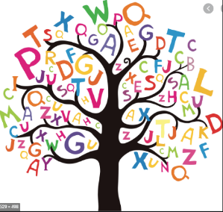
The national curriculum advises that children from each year group should learn a set of age appropriate words. Find the appropriate age group for your child in the link below.
https://www.spellzone.com/word_lists/lists-curriculum.cfm
Every child has been given a spelling bank that should be stuck in their reading record. This should be with them at all times. When your child asks for a spelling or we notice a misspelt word that should be spelt correctly such as “there” or “when” they will be encouraged to write this down. This then avoids children practising words they are already confident with, but also allows children to focus on their personal ‘tricky words’ until they feel confident enough to use them. Please spend time to practise these with your child. Find some new and interesting ways to practise spellings below. There will not be a formal test.
https://www.thoughtco.com/ways-to-practice-spelling-words-2086716
We have found in the past; children will be given a list of 10 weekly spellings and get 10/10 each week but they were still being misspelt in their written work. Every half term we want to send home a list of spelling rules, so they have the tools to apply this to any word. You can help your child with this or below is a link for a free online dictionary for children. (also available as an app/you can buy a physical dictionary)
https://kids.wordsmyth.net/we/

Reading
Ms Reid (Year 4 Teaching Assistant) works very closely with the teachers on reading objectives and reads with every child once a week, during this time she is questioning children on the book and new words. She will now be checking that your child is reading 3 times a week and their reading record is dated and signed by an adult or sibling (+16). The children that are doing this consistently will be rewarded. Your child may read a school-book or one from home. Below is a list of differentiated questions you could ask your child about the story they are reading.
https://www.rtsd.org/cms/lib/PA01000218/Centricity/Domain/841/Reading%20Comprehension%20Questions.pdf
Maths
We are currently following WhiteRose. If you wish, please find a link below which will give you access to schemes of learning, assessment sheets for each topic/term, parent workbooks, problem of the day and an interactive whiteboard. We are covering objectives from year 3 and 4.
https://whiterosemaths.com/resources/primary-resources/
So far, we have completed the following topics; Place value, Addition and Subtraction, Length and Perimeter. We are starting Multiplication and Division. Most children are confident with the methods but have anxiety around problem solving/mathematical language – It is important for children to justify their answers and have fluency/logical reasoning. This will be our priority moving forwards.
Timestables are fundamental! Children should know their facts by rote. If you feel your child is confident, please also test them on division facts. 4x6 = 24 and 24÷6=4. (You can find colour by number timestable sheets on google images, these will help if your child is more creative).
Below you will find links for various topics. Ask your child what they have been learning about in their Maths lesson. If they express their anxiety around subtraction, then you can solely search for that skill.
https://www.topmarks.co.uk/
https://www.bbc.co.uk/bitesize/subjects/z826n39
English
We know children have some anxieties around writing. We try to do a piece of writing every two weeks. We spend lots of time building up to this through drama, grammar lessons and planning. We encourage the children to take pride in their work through presentation and handwriting. It is also a very important skill in year 4 that they can proofread and up-level their work. The link below provides you with a different photo every day. It comes with a story starter, questions and sentences to up-level if your child enjoys doing a “cold” write which means there is no pressure they can simply enjoy writing.
https://www.pobble365.com/
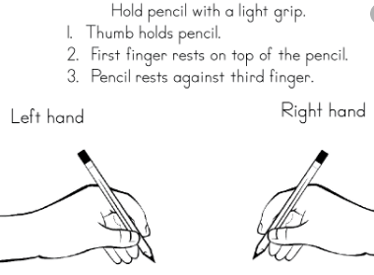
Handwriting
Please see the image provided to check your child’s pencil grip.
We are doing ‘cursive’ handwriting and moving forward will be looking to give out pen licenses to those children who’s handwriting is neat, joined and doesn’t require constant rubbing out or corrections.
Below is a website with various handwriting practise sheets, please focus on the letters your child struggles to write clearly and then move on to the next before forming words and sentences during their handwriting time.
https://kidzone.ws/cursive/

