Year 5
Parent Booklet
Dear Parents,
In light of parents evening, it has come to our attention that many of you are concerned over gaps in your child’s knowledge due to the current pandemic. We appreciate this and have taken on board your suggestions to help them catch back up to speed. Please remember we are all in the same storm but every child is in their own boat with regards to where they are educationally. You are not alone in how you are feeling and we are here to support and help our children prosper.
For a lot of children, routine and consistency are very important, however please bear with us for potential timetable/teacher changes. Please note that both teachers work very closely together to share information.
We have been so overwhelmed with the support you have shown us so far this year and the children seem so happy to be back learning again! We have put together some of the things we are working on and how you can help if you wish. If your child finds something too difficult try the objectives from a previous year group as this is what we do in class. Feel free to send in any work your child does at home and we will reward this!
Kind Regards,
Miss Ackernley and Ms Davies

Spellings
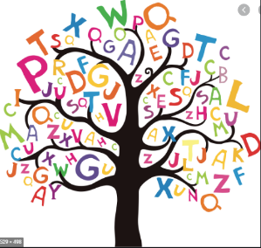
The national curriculum advises that children from each year group should learn a set of age appropriate words. Find the appropriate age group for your child in the link below.
https://www.spellzone.com/word_lists/lists-curriculum.cfm
Find some new and interesting ways to practise spellings below. There will not be a formal test.
https://www.thoughtco.com/ways-to-practice-spelling-words-2086716
We have found in the past; children will be given a list of 10 weekly spellings and get 10/10 each week but they were still being misspelt in their written work. Every half term we want to send home a list of spelling rules, so they have the tools to apply this to any word. You can help your child with this or below is a link for a free online dictionary for children. (also available as an app/you can buy a physical dictionary)
https://kids.wordsmyth.net/we/

Reading
Mrs Ibgui (Year 5 Teaching Assistant) works very closely with the teachers on reading objectives and we will try to read with the children as regularly as we can. Once we receive new reading records, we will be checking that your child is reading at least 3 times a week and their reading record is dated and signed by an adult or sibling (+16). The children that are doing this consistently will be rewarded. Your child may read a school-book or one from home. Below, is a list of differentiated questions you could ask your child about the story they are reading.
https://www.rtsd.org/cms/lib/PA01000218/Centricity/Domain/841/Reading%20Comprehension%20Questions.pdf
Please ensure your child is reading a variety of different text types, including fiction and non-fiction, as this will help expand their vocabulary and knowledge. Here is a Year 5 reading spine with some great book ideas (at parent’s discretion obviously) as lots of you asked for ideas at parents evening:
https://shop.scholastic.co.uk/search/search?log=t&search%5Bquery%5D=%22%23reading-spine-year-5%22
Maths
We are currently following WhiteRose. If you wish, please find a link below which will give you access to schemes of learning, assessment sheets for each topic/term, parent workbooks, problem of the day and an interactive whiteboard. We are covering objectives from Year 4 and 5. There are also other Year groups available for ‘gap filling’ and some of you may wish to stretch your child with the Year 6 Vimeo links and explanations.
https://whiterosemaths.com/resources/primary-resources/
So far, we have completed the following topics; Place value, Addition and Subtraction, Length and Perimeter. We are starting Multiplication and Division.
Times tables are fundamental! Children should know their facts in and out of sequence. If you feel your child is confident, please also test them on division facts. 4x6 = 24 and 24÷6=4. (You can find colour by number times table sheets on google images, these will help if your child is more creative).
Below you will find links for various topics. Ask your child what they have been learning about in their Maths lesson. If they express their anxiety around subtraction, then you can solely search for that skill.
https://www.topmarks.co.uk/
https://www.bbc.co.uk/bitesize/subjects/z826n39
English
We try to do an independent piece of writing at least every two weeks. We spend lots of time building up to this through role play, grammar lessons and planning carefully. We encourage the children to take pride in their work through presentation and handwriting. It is also a very important skill in Year 5 that they can edit and up-level their work. The link below provides you with a different photo every day. It comes with a story starter, questions and sentences to up-level if your child enjoys doing a “cold” write, which means there is no pressure, they can simply enjoy writing!
https://www.pobble365.com/
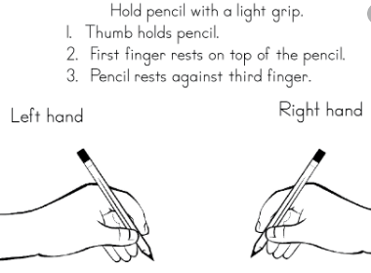
Handwriting
Please see the image provided to check your child’s pencil grip. In school, we teach the children ‘cursive’ handwriting and give out pen licenses to those children whose handwriting is neat, joined and consistent.
Below, is a website with various handwriting practise sheets, please focus on the letters your child struggles to write clearly and then move on to the next before forming words and sentences during their handwriting time.
https://kidzone.ws/cursive/

