Year 3
Parent Booklet
Dear Parents,
In light of parents evening, it has come to our attention that many of you are concerned over gaps in your child’s education and wellbeing around COVID-19 and lockdowns. We appreciate this and have taken on board all of your worries, please remember that every child is in their own boat in the same storm. You are not alone in how you are feeling and we are here to support you.
For a lot of children routine and consistency is very important however please bear with us for timetable/teacher changes. Please note that all year 3 teachers work very closely together to share information.
We appreciated your gratitude and hearing how happy your children are this year. We have put together some of the things we are working on and how you can help if you wish. If your child finds something too difficult try the objectives from a previous year group as this is what we do in class. Feel free to send in any work your child does at home and we will reward this!
Kind Regards,
Mrs Brennan, Mrs Anderson, Ms Marshall and Mr Caplan

Spellings
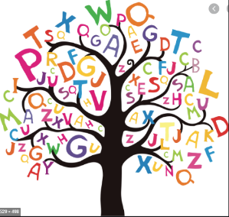
The national curriculum advises that children from each year group should learn a set of age appropriate words. Due to the children missing a large portion of Year 2 we are still working on the Year 2 High Frequency Words before moving on to the Year 3 word bank. Find the appropriate age group for your child in the link below. Please spend time to practise these with your child. Find some new and interesting ways to practise spellings below.
https://www.spellzone.com/word_lists/lists-curriculum.cfm
https://www.thoughtco.com/ways-to-practice-spelling-words-2086716
https://kids.wordsmyth.net/we/

Reading
Below is a list of differentiated questions you could ask your child about their reading book when they are reading their book weekly. We send home a new book every Friday.
https://www.rtsd.org/cms/lib/PA01000218/Centricity/Domain/841/Reading%20Comprehension%20Questions.pdf
Maths
We are currently following WhiteRose. If you wish, please find a link below which will give you access to schemes of learning, assessment sheets for each topic/term, parent workbooks, problem of the day and an interactive whiteboard. We are covering objectives from year’s 1, 2 and 3.
https://whiterosemaths.com/resources/primary-resources/
So far, we have completed the following topics; Place value and Addition and Subtraction. Most children are confident with the methods but have anxiety around problem solving/mathematical language – It is important for children to justify their answers and have fluency/logical reasoning. This will be our priority moving forwards. We are also working on the children’s positive mathematical mindset. Please help identify math and problem solving in your day to day as many children struggle to see how often they are doing maths and feel that if they struggle in a maths lesson they are automatically “bad” at maths.
Times tables are fundamental! Children should know their 2, 5 and 10 facts by rote and beginning to know their 3, 4, 6 and 9. You can find colour by number times table sheets on google images, these will help if your child is more creative.
Below you will find links for various topics. Ask your child what they have been learning about in their Maths lesson. If they express their anxiety around subtraction, then you can solely search for that skill.
https://www.topmarks.co.uk/
https://www.bbc.co.uk/bitesize/subjects/z826n39

English
We know children have some anxieties around writing. We try to do a piece of writing every two weeks. We spend lots of time building up to this through drama, grammar lessons and planning. We encourage the children to take pride in their work through presentation and handwriting. It is also a very important skill in year 3 that they can proofread and up-level their work. The link below provides you with a different photo every day. It comes with a story starter, questions and sentences to up-level if your child enjoys doing a “cold” write which means there is no pressure they can simply enjoy writing.
https://www.pobble365.com/
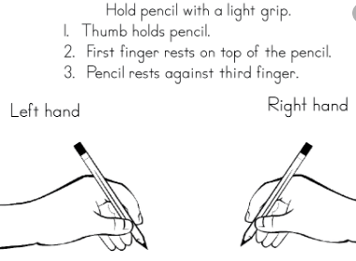
Handwriting
Please see the image provided to check your child’s pencil grip. We are doing ‘cursive’ handwriting, and complete weekly handwriting lessons.
Below is a website with various handwriting practise sheets, please focus on the letters your child struggles to write clearly and then move on to the next before forming words and sentences during their handwriting time.
https://kidzone.ws/cursive/

