Speech Language and Communication: Learning at Home
Handwriting
Handwriting is an excellent way to develop fine motor skills. Gripping the pencil strengthens the muscles in the hand and fingers while forming the letters improves control over those muscles and creates a stronger bond between the brain and the hands. Over time, you'll see your child favour one hand over the other.
Handwriting is important because it is a basic tool used in many subjects: taking notes, taking tests, and doing classroom work and homework.
There are 3 stages of handwriting. Activities can be chosen from the appropriate stage your child is working at.
1. Pre writing patterns

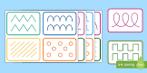
Pre-writing skills are the skills children need to develop before they are able to write. These skills contribute to the child's ability to hold and use a pencil, and the ability to draw, write, copy, and colour. These are the pencil strokes that most letters, numbers and early drawings are comprised of.

Video example
https://www.youtube.com/watch?v=6ykBbDS5B5Q
The above link has a video for parents showing how to develop pre writing skills with their child.
http://www.megaworkbook.com/colors-shapes-and-patterns/line-and-curve-tracing
The above link has a set of printable worksheets for practicing pre handwriting skills. There are worksheets to practice straight and curved lines. It is advisable to start with straight lines. Click on the worksheet of your choice and it can be printed off.

*Please let your child’s teacher know if you don’t have access to a printer.

Single Letter Formation

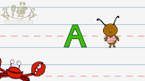
Video examples
https://www.youtube.com/watch?v=cRrYgWH8ffw
The above link has a song which your child can join in with to show how to correctly form the letters of the alphabet.
https://www.abcya.com/games/letter_trace
The above link has an online letter tracing activity.
Worksheets
http://www.first-school.ws/theme/alphabetp12.htm
The above link has a selection of worksheets from A-Z which you can use with your child to practice writing the letters of the alphabet. There are several worksheets available for each letter. Choose the worksheets you think your child will enjoy. They can be printed off.

3. Joining letters
When your child is confident in forming single letters you can introduce the concept of joining letters (cursive writing).
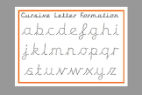
Below are some steps to follow:
Step 1: Introduce one cursive letter at a time. Think of your child as re-learning to
write the alphabet again.
Step 2: Begin with teaching lowercase (small) cursive letters.
Step 3: Then teach uppercase (capital) cursive letters.
Step 4: Then your child can start to copy simple sentences.

*Please let your child’s teacher know if you don’t have access to a printer
Writing Wizard App
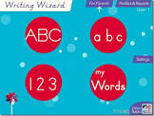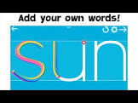

.https://www.youtube.com/watch?v=qH-zulxZ_pE

https://www.youtube.com/watch?v=ijUL39H8bJU

The above links show demonstrations of a tracing app called Writing Wizard which can be installed onto an I Pad, I phone or android device and how to use it. Your child can practice pre- writing patterns, upper case letters, (capital), lower case letters (small )., writing words and then sentences. The app can be found in the Google Play Store. This app is a fun way for your child to practice tracing letters of the alphabet

https://www.youtube.com/watch?v=LxS1vq8h35g
The above link shows a demonstration of the app with cursive examples.

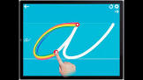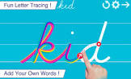

Sensory based writing activities.
https://thislittlehomeofmine.com/handwriting-practice-ideas/
The above link has a selection of practical ideas which you can use with your child at home. .The activities use items which are easily accessible.to use at home. Activities can be chosen which you think your child will enjoy.
Video Examples
https://www.youtube.com/watch?v=Qq90WOn3xAY
The above link has a video showing a sand tray activity you can use with your child at home.

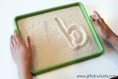

https://www.youtube.com/watch?v=WMg7spX7qWc
The above link has a video showing how to form letters using playdough.
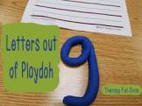

https://www.youtube.com/watch?v=ZRrqo3sUfDA
The above link has a video showing how to use cookie cutters to form letters of the alphabet.
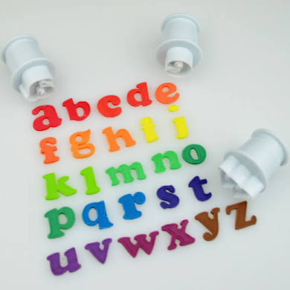

https://www.youtube.com/watch?v=iBSrJCNY5-E
The above link has a video of a child practicing writing letters on a whiteboard. You will need a board, some dry white marker pens and a cloth for wiping the board.
