How to help when your child needs support with reading

If your child is struggling with reading a word, or is reading it incorrectly to you, resist the temptation to jump in and give the correct word. Remember that it is better in the long term to teach a man to fish than to just give him a fish. Instead, remember the three P’s:
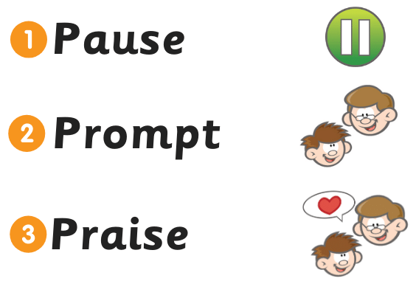

Pause
If your child is making a substitution for the word on the page, (e.g. substituting ’house’ for ‘horse’) give him or her a chance to self-correct. If he or she does not, you might ask “Does that make sense?” If your child continues to read the word incorrectly or is not able to produce a word at all, move on to ‘Prompt’.

Prompt
Your first prompt should be: “Sound it out”. Your child should sound out the word, starting with the first sound and making his or her way through to the last sound, blending the sounds together.
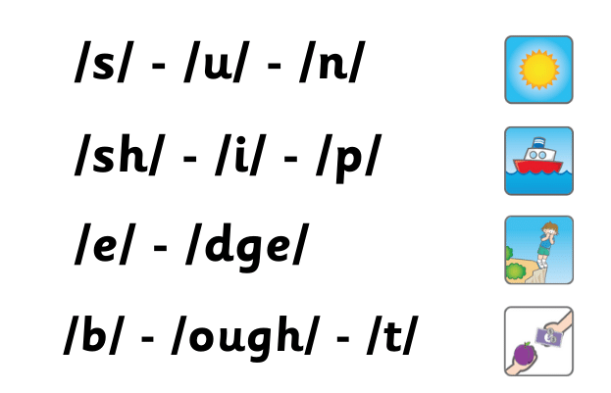
As you can see in the examples below, one sound may be represented by one, two, three or even four letters.

This video explains how to sound out each alphabet letter and the blending of words
https://youtu.be/jy0ystXuDcs

This video shows how you and your child can break down words by letters and sounds using fun robot arms
https://youtu.be/wvtaLPmHfk0

Your second prompt should look at the letter sound which your child is struggling with. For example, the word ‘clown’ – ‘cl-ow-n’. If your child is struggling with the ‘ow’ sound, you could say the ‘ow’ sound “ow, like in c-ow, cow”. Encourage your child to say the sound.
This video looks at and helps to explain to parents how to ‘blend’ words
https://youtu.be/I43tv5aIYTI

Your last prompt should be “Try the word again”.
Only if your child is still unsuccessful should you supply the correct word. Remember to be a good role model by sounding out and blending to produce the word.

Praise
Praise your child verbally for hard work. How and when you praise is important. If your child is reading a sentence, you should probably wait until the end of the sentence before praising, so as not to interrupt the flow or sense.
Rather than saying “Good job” or something similar, give feedback about what he/she did, for instance, “You sounded that out really well” or “You broke that big word up just the way you needed to”. This will hopefully reinforce the use of the helpful strategy.
See the three P’s in action in this video: https://youtu.be/R9GRrOrXeAE?t=90

Compound and Multi-syllable Words
If your child is having difficulty with or is misreading a word that has more than one syllable, then you will need to help him or her to break the word down into syllables and sound out each syllable in turn.
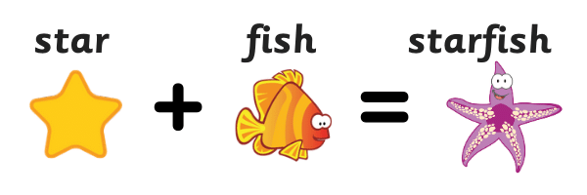
Let’s use an example of a multi-syllable word called a compound word – a word made up of two smaller words. Let’s use the word ‘starfish’:

Your prompt could be:
“That word is made up of two smaller words. Can you tell me what one of those words is? What is the other word? Now put them together.”

If your child cannot identify the two parts of the word, cover the second with your finger and ask the child to sound out the first one. Like so:
Then cover the first part and ask the child to read the second one before blending the two.

Other Multi-syllable Words
Because every syllable has a vowel sound, the first step in breaking down a long word that is not a compound word is to look for the vowels.
Let’s look at the word ‘cinema’ as an example. This word has 3 vowel sounds (cin-e-ma) so it has 3 syllables.

Tricky Words

Words that cannot easily be sounded out from beginning to end, because they contain an uncommon letter-sound correspondence, are called ‘irregular’ words or, in kid-speak, ‘tricky’ words. There are usually some ‘regular’ letter-sound correspondences in the word, so you should encourage your child to say these.
You will then have to teach the ‘tricky’ part, e.g. “In the word ‘was’, the ‘a’ is representing the short /o/ sound and the ‘s’ representing the sound /z/.

Many children struggle to read but it can be hard to know what you can do to help them.
This video helps you to understand what you can do to help your child if they are struggling to read. It runs through some problems your child may be experiencing and how you can help. Some great advice for parent/teacher links and conversations you may wish to have with your child’s class teacher.
https://youtu.be/Q7s2KbQpJ-A

