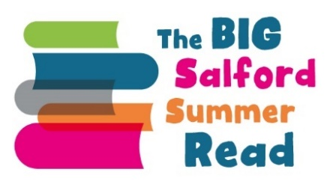

Make Time For a Read

Salford libraries are excited to introduce The Big Salford Summer Read. Our summer read will be running in all Salford libraries from now until Friday 17th September.

It is open to all children aged 4-11 years and is free of charge. Children simply need to read three books (including eAudiobooks and eBooks) or more, to receive a certificate, and be entered into a prize draw to win a Kindle. Everyone who takes part will receive a colourful reading record, chock-full of mini challenges to maintain motivation whilst on their reading voyage. We are encouraging children to commit to completing one mini-challenge per week to keep motivated. For each mini challenge successfully completed, they receive stars to mark them as complete. Once their reading record is complete, they will receive a medal (while stocks last). What’s more, they'll also be entered into a prize draw to win an Annual Family Swimming Pass. The prize draws we are offering this summer will appeal to both reading enthusiasts and aquatic aficionados, so we have something to entice a range of readers! There will also be a prize for the school who has the greatest proportion of children completing the Big Salford Summer Read.

Our libraries have recently benefitted from a fresh injection of children’s library stock, with lots of familiar favourites and exciting new authors to try. Children have also access to a wide range of popular titles via the BorrowBox app, including eAudiobooks. So many wonderful books are just one click away!

Each library will have a weekly activity to collect and try at home. We will also be running some fabulous summer activities for children, which can be found at www.salfordcommunityleisure.co.uk, our Facebook page (Salford Community Libraries) and Instagram account (salfordlibraries).
Due to restrictions imposed by Covid-19, we have been unable to offer assemblies this year. We would be grateful if you could spread the word about our exciting summer initiative, which will encourage reading over the summer holidays.

