Online safety is important because it helps to keep children safe so they can enjoy, explore and have fun!
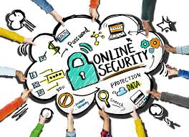
The Internet is great because
- You can learn lots of things
- You can have lots of fun
- It can help with our school work
- You can stay in touch with friends or family
Some online dangers include: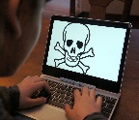
Cyber Bullying – nasty text messages and emails, swearing on X boxes.
Stranger Danger – Some people, who we talk to online, we don’t know personally, so they are strangers.
Bad Language – Sometimes when we are online, we can see or hear swear words that might upset us.
Content Online – Some material online is not suitable for children to look at.
Viruses – Some emails may contain viruses

When we are online, we should:
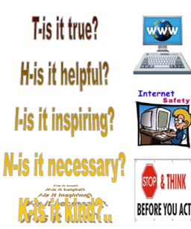

Who is responsible for Online Safety in our school?
- Mrs Pritchard
- Mr Hart
- Mr Pritchard
- Rabbi Simons
- All teachers and adults

People we should tell:
- Family
- Friends
- Teachers
- School Council
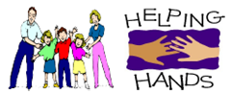
- PCSO Coulson

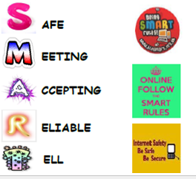
How should I behave online?

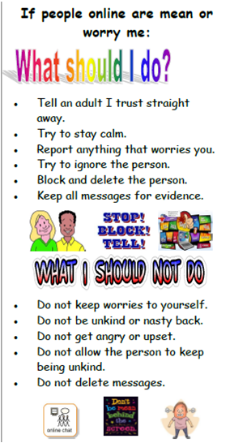
What our school does to respond to online safety issues.
- We take online safety seriously
- We listen to the children involved and offer support
- We investigate and look at evidence
- We make sure children face up to the consequences of their actions
- We contact parents or carers

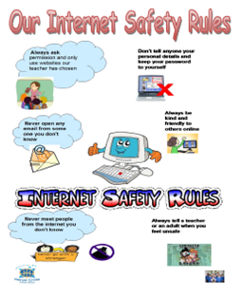
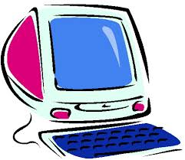

Online Safety
Leaflet

