BJCF Before & After

School Club

Before and After School clubs are available to children from Kindergarten - Year 6. The times are as follows;

Club | Time | Cost | Activities | Snacks
Before School | 7.45am-8.45am | £3 Per session  £1 for children attending Gym/Badminton | Board games, colouring, outside activities | Cereal, fruit, juice, water
After School | 3.30pm – 5pm | £4.50 per session | Arts, Craft, Games, Outside activities, Homework | Sandwich, fruit, juice, water
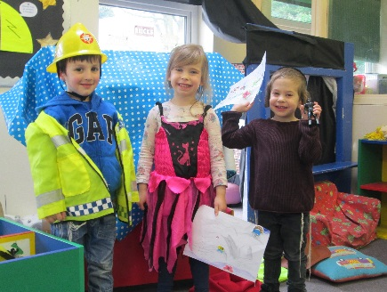
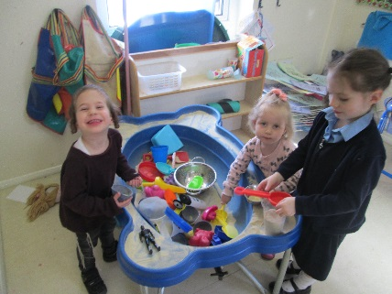
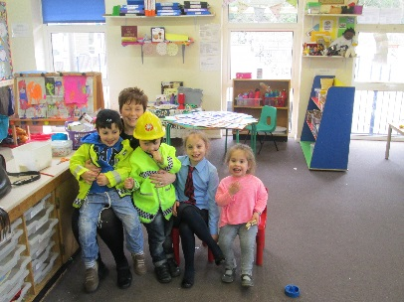

Payments for all clubs MUST be made in advance of your child attending. This should be made when you book to reserve your child’s place, on a daily basis when your child arrives or in advance of the term ahead. Please complete attached form and return it to the office.

Payments are to be made direct to Mrs Shepherd, School Club Manager in cash or chq.
Cheques should be made payable to BJPS. Where a bank transfer is preferred, this can be arranged and paperwork will be provided.

For insurance and organisational purposes, we cannot accept your child’s attendance at a club without prior payment.
PLACES ARE OFFERED ON A FIRST COME FIRST SERVE BASIS

For more details contact the school office – admin@bjps.net

SpringTerm 2016/17 After School Club

I confirm that my child …………………………………………………………. (full name)

Class ………………..will attend the After School Club on the following days each week:

I WILL PAY WEEKLY/DAILY FOR THE DAYS MY CHILD ATTENDS

Mon Tues Wed Thur

- MONTHLY PAYMENT

Mon £49.50 Tues £54.00

Wed £58.50 Thur £54.00
I enclose remittance as ticked.
(Please tick as appropriate)
………………………………………………………………………………………………………………………

Breakfast Club

I confirm that my child ………………………………………….……… (full name)

Class ………………..will attend the Breakfast Club on the following days each week:

I WILL PAY WEEKLY/DAILY FOR THE DAYS MY CHILD ATTENDS

Mon Tues Wed Thur Fri

- MONTHLY PAYMENT

Monday £33.00 Tuesday £36.00

Wednesday £39.00 Thursday £36.00

Friday £36.00

I enclose remittance as ticked.
(Please tick as appropriate)

Please find enclosed £…………………………………………………Cash/Cheque/I will pay by the Bank

on/before MONDAY 19th December 2016 (Please delete as applicable)

ACADEMY BANK DETAILS a/c no. 50552660 Sort Code 30 95 42

Signed…………………………………………………………………Parent/Guardian

PLEASE TAKE A COPY OF THIS SHEET FOR YOUR RECORDS BEFORE RETURNING IT TO SCHOOL WITH YOUR CONTRIBUTION

