Broughton Jewish Lunch Menu
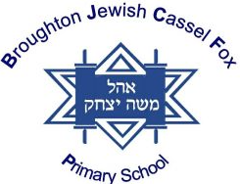
Week 2
 | Monday | Tuesday | Wednesday | Thursday | Friday
Main Meat Option | CHICKEN SCHNITZEL SERVED WITH PASTA | MEAT  RISSOTTO | ROAST  CHICKEN IN GRAVY | MEAT PIE IN A  RICH TOMATO SAUCE WITH A PUFF PASTRY CRUST | FISH FINGERS OR FISH GOUJONS
Main Vegetarian Option | VEGETARIAN BURGER | VEGETARIAN RISSOTTO | VEGETARIAN  HERB SAUSAGES | VEGETARIAN CHICKEN STRIPS  IN A PUFF  PASTRY | VEGGIE SCHNITZELS
Side | BAKED BEANS | SWEETCORN  BOILED RICE | COUS – COUS  GREEN BEANS | CREAMED POTATO  MIXED VEGETABLES | PEAS  CHIPS
Dessert | FRUIT BAR | SYRUP SPONGE | MIXED FRUITS | FAIRY BUNS | BISCUIT
DAILY SNACKS AVAILABLE –
SANDWICHES/JACKET POTATOES/SALAD & FRUIT BAR

